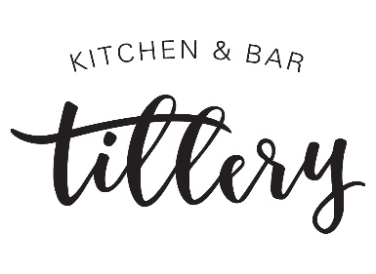

Monday, December 31st, 2018
New Year’s Eve Dinner
Choice of:
1st Course (Soup) | Duck Wonton  Braised thigh, Sichuan peppercorn, bone broth  Winter Harvest (Gluten-free, Vegan)  Carrot, shiitake, fried lotus root  White pairing: Terra d’Oro Pinot Grigio  Red pairing: Sangre de Toro Tempranillo

2nd Course (Salad) | Arugula Salad (Gluten-free, Vegan w/o feta)  Pear vinaigrette, feta, parsnip crisp  Farro Salad (Vegan)  Miso dressing, dried cranberry, fried kale  White pairing: Marques de Riscal  Red pairing: Lewis Texas Red Wine Blend

3rd Course (Entrée) | Prime Rib (Gluten-free)  Black-eyed peas, grilled broccolini, parsnip puree  NYE Curry Rice (Gluten-free, Vegan)  King oyster mushroom, rainbow carrot, x  White pairing: Skyfall Riesling  Red pairing: Cahors Malbec

Finale (Dessert) | Sweet Potato Pie  Candied chestnut, sake buttercream  Yuzu Sorbet (Gluten-free, Vegan)  Candied ginger, azuki bean jam

After Dinner Drinks
Fairlady
Titos Vodka, Yuzu, Coconut Cream
&
The Austinite
Old Forester Aged and infused with Duck Confit, Sweet Vermouth, Bitters

*Consuming raw or undercooked meats, poultry, seafood, shellfish, or eggs may increase your risk of foodborne illness.

